ACM Word Template for SIG Site

1st Author
1st author's affiliation
1st line of address
2nd line of address
Telephone number, incl. country code
1st author's E-mail address
2nd Author
2nd author's affiliation
1st line of address
2nd line of address
Telephone number, incl. country code
2nd E-mail
3rd Author
3rd author's affiliation
1st line of address
2nd line of address
Telephone number, incl. country code
3rd E-mail

EVALUVATION AND OBSERVATIONS

This section describes the various evaluations done on the modified CloudKon to check its availability, scalability, and performance. In all our experiments we used m1.medium instances of Amazon EC2. We have run all of our experiments on us.east.1 datacenter of Amazon. All of the instances had Linux Operating Systems. Our framework works on any OS that has a JRE 1. 6 (or above) running on it. We have used bash scripting language to semi automate the experiments. This is the same set up that was used in original CloudKon’s evaluation.

Throughput and Scalability
In order to measure the throughput and latency of our system we run sleep 0 tasks on worker nodes. We have evaluated the performance of CloudKon on multiple instances, starting from 1 instance and extending the experiment up to 64 instances. There are 2 client threads and 4 worker threads running on each instance. Each instance submits 16000 tasks. On the largest scale (64 instances) our system runs 1024000 tasks on each experiment.
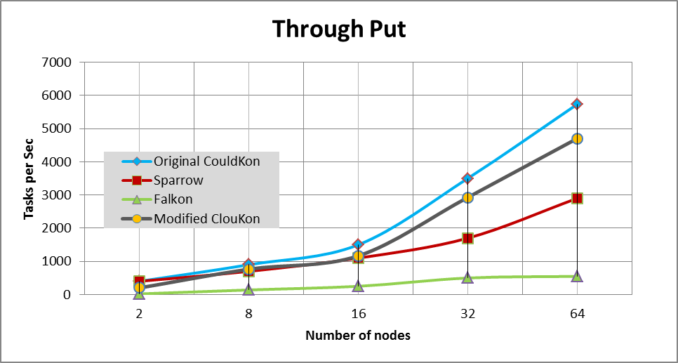
Figure 1. Comparing the throughput of different JobExecution systems.

.

We evaluated the throughput of modified CloudKon just the way Original CloudKon was evaluated i.e. we scaled it from 1 to 64 instances running 16000 to 1024000 tasks. The results show that Modified CloudKon achieves almost linear speedup starting from 235 tasks per second on 2 instances to 4704 tasks per second on 64 instances. Therefore we predict that our solution scales at the same rate on larger scales.
We can observer a drop of around 1000 tasks per second in comparison with the Original CloudKon and it’s due to 2 main following reasons.
SQS is managed by Amazon and it scales automatically when the load on the queuing system increases; whereas in out model as of now we don’t have an automatic scaling of Hazelcast cluster enabled. Currently we used m2.xlarge 10 node cluster of for this and this is acting as a bottle neck. A good mixture of m2.2xlarge nodes and c1.xlarge nodes forming the cluster which scales automatically based on load will improve the performance of the system and we are working towards that.
Original CloudKon was submitting tasks via Google protocol buffers. The tasks mainly contained sleep commands and hence this light weight protocol results in efficient use of the system and very high performance. In our modified version we are submitting tasks which are java serializable Thread objects. The overhead involved in serialization (at client end while submitting tasks) and de-serialization (at Worker end) limits the performance of the system. But we believe that this tradeoff is justified since now the system can support complex tasks which can run independently.
The following graph shows a closer analysis of a the system when submitted to heavy load of small task length. 32 clients submitting 62500 tasks of 1 millisecond to 128 executors running on 32 nodes all running on m1.medium instance of Amazon EC2 . A 10 node m2.2xlarge nodes were used as the Distributed queue component and a 2 node m2.2xlarge Cassandra cluster was used as monitoring database.

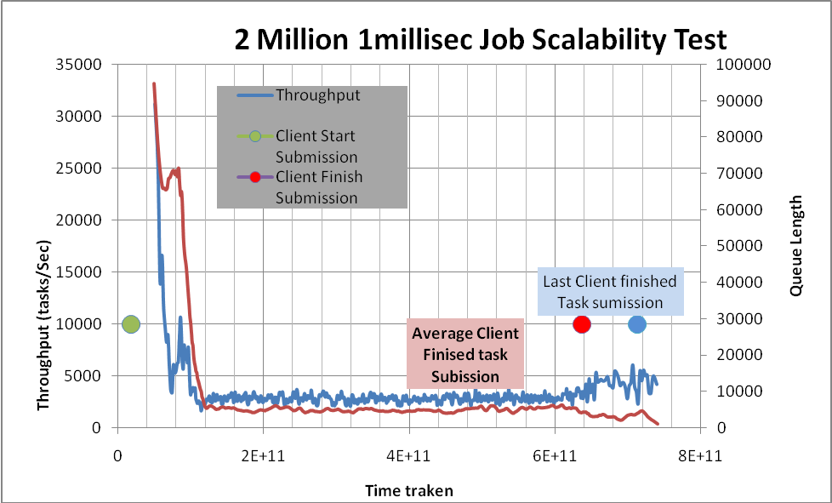
Figure 1. Throughput variation during system execution (2million 1 mill sec jobs)

.

We can clearly see the average through put above 3000 task per second (3527 tasks per sec) which is at par with the through put of original CloudKon. We can clearly see a fall of through put in the initial stages and then a stabilized through put and later a increase in through put towards the end. The very high through put at the start is because all workers are able to retrieve tasks from already filled local task queues of clients (clients advertise them self only when there are 10% tasks in their local queues).The stabilized state of throughout is because of the bottleneck caused by slow speed of client submissions; i.e. clients are still busy submitting tasks in their local queue delaying the workers from pulling the jobs. This becomes clear as we can see a jump in through put towards the end when clients have finally finished all their submissions. The red dot indicates when the most of the client finished submitting all their tasks.
To further measure how the system behaves when there are tasks in Wait queue we increased the job lengths to 1 second.

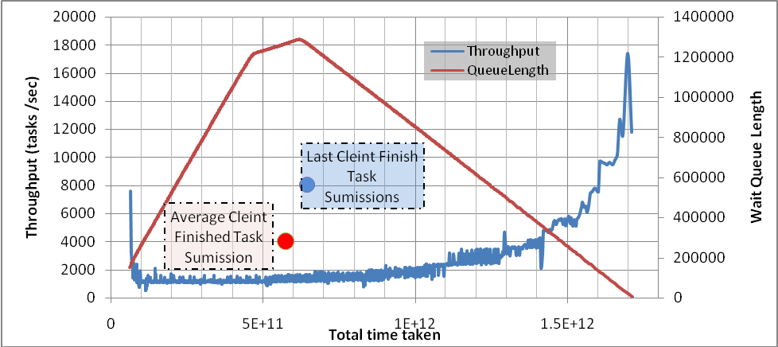
Figure 1. Throughput variation during system execution (2million 1 second jobs)

.

Since the task length is higher this time we can see that the through put is not high during the start phase in comparison with the previous experiment observation; and it is quickly stabilized. The stabilization is mainly because of the task length and we see the trend continue till clients finish submitting their tasks in the queue.
Red dot marks the time when most of the clients have finished their submissions and blue dot indicates the time when the last clients completes the task submission phase. It can be seen that there is a incremental increase in through put after this point. This is due to the fact that the Hazelcast queue component is freed form servicing the client submissions ; which is 20% of the total Hazelcast clients (32/160) and is only servicing the workers. The access is always of a "take" from the queue and no further modifications (puts) are made to this queue. Since Hazelcast cluster is a consistent distributed store; this frees it from a lot of internal overheads associated with cluster synchronization.
The next major jump happens after the yellow dot; which indicates the completion of half of the clients. We attribute this again to the lessened load on distributed Hazelcast cluster; because by now it needs to service only 40% of its total load. As more and more clients finish the load on the cluster decreases and we can see increase in through put. The added fact that by now most of the workers will be servicing a lower number of clients adds to reasons for the increase in through put.
This strengths our assumption that with an auto scaling Hazelcast queue component we can achieve much higher through put with the same model. We intend to study this further.
In comparison to original CloudKon our model does not have the issue of duplicate task controller. Hazelcast uses a Concurrent Distributed Queue and provides us with exactly once delivery of tasks unlike SQS.
We measured the through put of our model while doing File IO operations of different sizes. We did this in order to check how the system behaves when there is IO bound tasks involved.
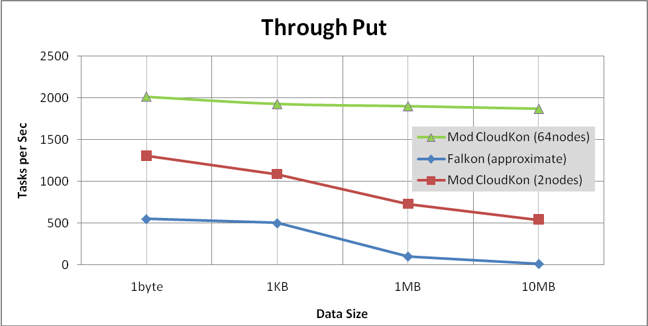
Figure 1. Through put during IO operation

.

We can see a drop of 50% in through put in comparison with sleep 0 tasks; which is mainly due to the involved file IO. But subsequently we can see that the through put is not degrading as much as it was for Falkon (the data for Falkon is approximated from the reference []). This is mainly because due to the centralized model of Falkon limiting its through put and because of the optimized EBS volumes CloudKon uses for writing.

Efficiency of modified CloudKon

Efficiency of the system dictates its ability to run short tasks with less than a second task length efficiently. The following graph shows the efficiency of the system for various task lengths.
We can see that the system nears optimal efficiency of 1 when the task lengths are high. We can see a clear jump in efficiency for the modified version of CloudKon once the task lengths exceed the 32millisecond mark. This is mainly due to the fact that the overhead associated with serialization and de-serialization of the Thread objects (used as tasks) is behaving as a bottle neck for tasks which have length less than 32 milliseconds. Once this threshold is crossed the task length becomes the main component for execution. We can see that the for tasks of length 1 sec we are reaching ~90% efficiency; indicating that modified version is not adding any overhead
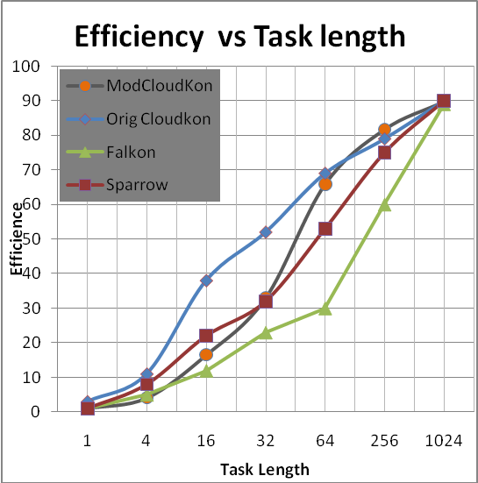
Figure 1: Efficiency vs. Task Length Analysis of various task scheduling systems

.

Impact of Late Advertisements of tasks

As explained in section we have a advertisement based model where each client advertises its own local queue information in a global queue which all the workers listen to. It’s critical that we find a right time for these advertisements to be made; because if we do it too early then we may end up in a scenario where Workers tried to pull tasks from the local queue and the local queue was not filled. This will lead to huge performance loss if workers use up all the advertisements made before the client fills the local queue.
And on the same line if we delay the advertisements; i.e. wait till the clients fill the local Queue with tasks and then do the advertisements; it would lead to wastage of worker nodes utilization. Since a worker will service a client till the tasks from the clients local queue is not completed another issue is that it late advertisements lead to starvation of few clients. As we can see from the image below which shows the start and stop times of 64 clients (32 nodes); few of the clients (green ring ) are started and finished quiet early and some clients (red ring) are serviced only towards the end.
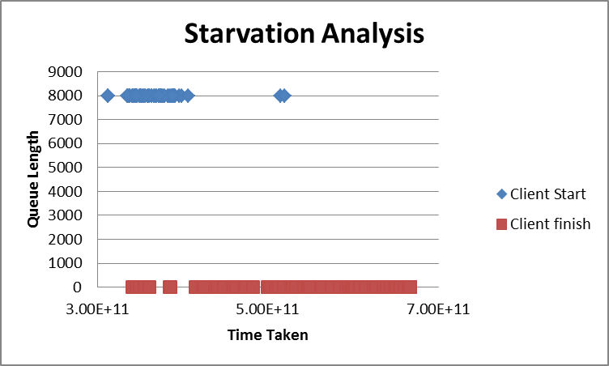
Figure 1: Start and End time analysis of Clients

.

A deeper analysis of the individual queue lengths of these respective clients further establishes this fact. The client that does the advertisement first gets picked initially and finishes early. The starved client which was only able to advertise towards the end has to wait almost till the end of the experiment. The steep fall of the response Queue length is a also an indicator that all the workers are working for this starved client towards the end giving a quick response to the tasks in queue.

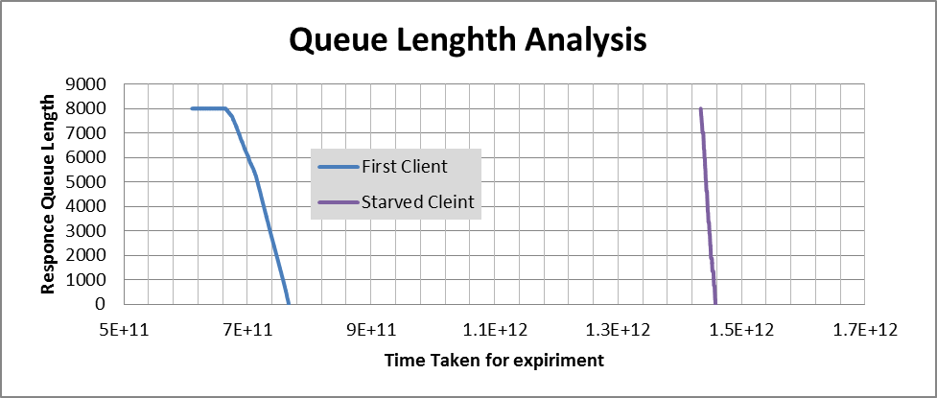
Figure 1: Response Queue Lengths of Clients

.

Hence we implemented a staggered advertisement model where the client does the advertisement of local queue information once the client has filled some percentage (configurable) of tasks in its local queue. The following graph shows the result of this implementation where the clients did their advertisements once 10% of total tasks to be submitted are put in local Queue. There is a clear closer grouping of client starts and finishing timings; indicating a fair scheduling policy.

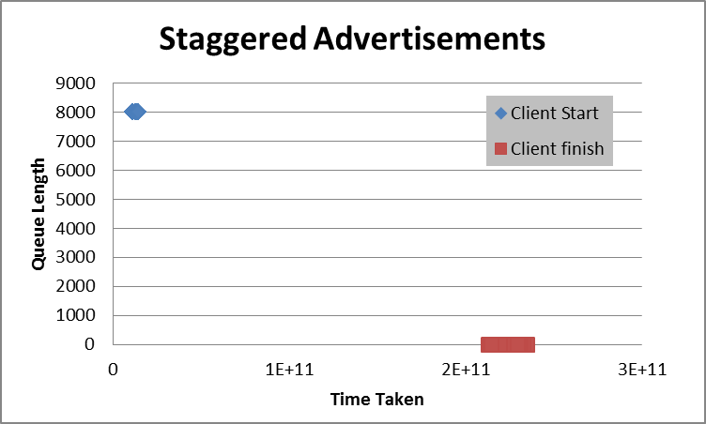
Figure 1: Start and End time analysis of Clients

.

Though our model provides the user to configure this percentage value it’s highly recommended that the user takes a reasonable approach in setting this field. I.e. User can choose a very safer advertisement policy i.e. by increasing this percentage value (80-90%); but then he risks potential starvation and resource wastage. On the other hand a very low percentage (0-10%) set can result in a bigger problem where the workers use up the advertisements made by the client (while the client was filling up its local queue), resulting in a really slow recovering system. As explained in Section X ; we have an automatic recovery mechanism where the clients automatically redo advertisements when a time out happens and there are jobs in its request Queue

Availability

CloudKon had the inbuilt support of SQS which was a highly available queuing service which we have replaced with Hazel cast. We used 5 m2.xlarge machines to make the Hazelcast cluster which was our distributed queue component. We tested the availably of this service under a load of 64000 tasks and 4 nodes. We incrementally terminated 4/5 nodes forming the Hazelcast cluster while the clients and workers were executing and found that there was no loss of consistency (i.e. all the clients got the result for their submitted jobs) even with a loss of 80% of nodes. We attribute this behavior to the configurable replication feature available in Hazelcast; which allows us to set the nodes holding duplicate copies. We used a replication factor of 1 which means that the data will be backed up by one more node.
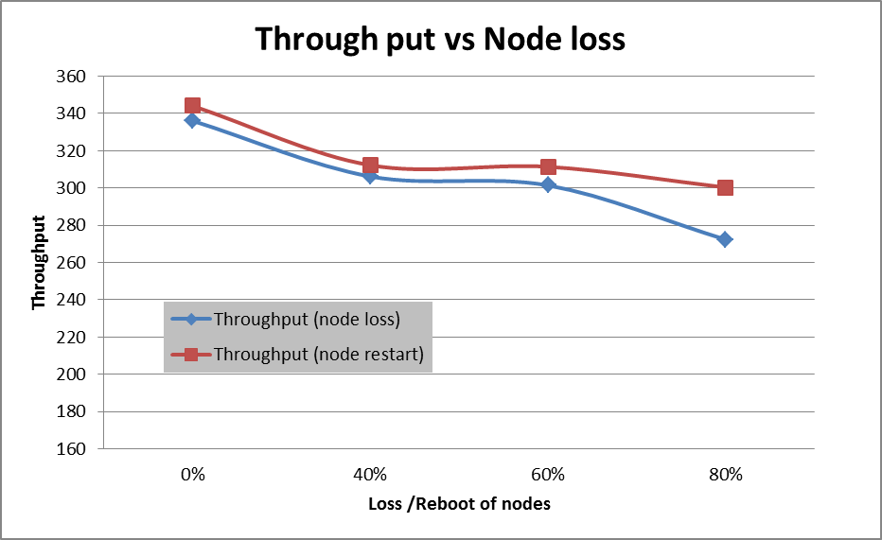
Figure 1: Through put degradation when node loss happens for Hazelcast Queue component.

.

As the figure represents there was a loss of throughput when the cluster had lesser number of nodes. This is because our system effectively uses all the nodes available in the Hazelcast cluster and balances the load in order to achieve optimal performance; and when the nodes in the cluster is less the system performance is bound by the performance of these nodes. A similar study was conducted by rebooting the nodes and we saw no consistency loss and a degradation of performance. The degradation in performance is due to the overhead involved for rejoining of the nodes to the cluster, re-distribution of data, re-allocation of load etc… internal to Hazelcast component.
We also needed to make sure that the Cassandra cluster we use for storing monitoring information was not a bottleneck in the system. We terminated the nodes forming the Cassandra cluster and watch the impact on performance. We tested the availably of this service under a load of 64000 tasks and 4 nodes. We did not find any loss in consistency or degradation in performance. This is due to the fact that the Cassandra cluster is used only to store monitoring information and has no impact on client or executor operations. We use a multi-threaded model for monitoring and separate threads are allocated to do the asynchronous monitoring ;so that the critical tasks (job addition, execution, completion etc...) are not impacted due to monitoring.

Impact of Resource allocation/utilization strategies

